**Challenge #2**

We need to write code that will query the Meta data of an instance within GCP and provide a

json formatted output. The choice of language and implementation is up to you.

Answer:

For the above task we are using Google cloud platform (GCP) to query the metadata of an instance. For this we are using a python code. Here I am implementing the task using a Virtual Machine, for this I have created an instance with 2vCPU and 4GB memory.

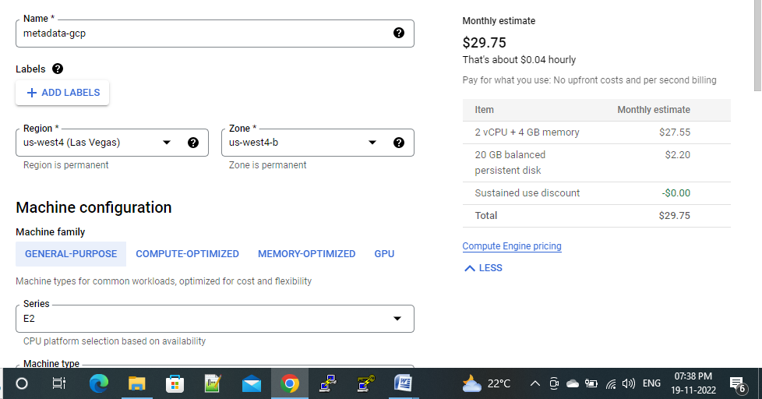

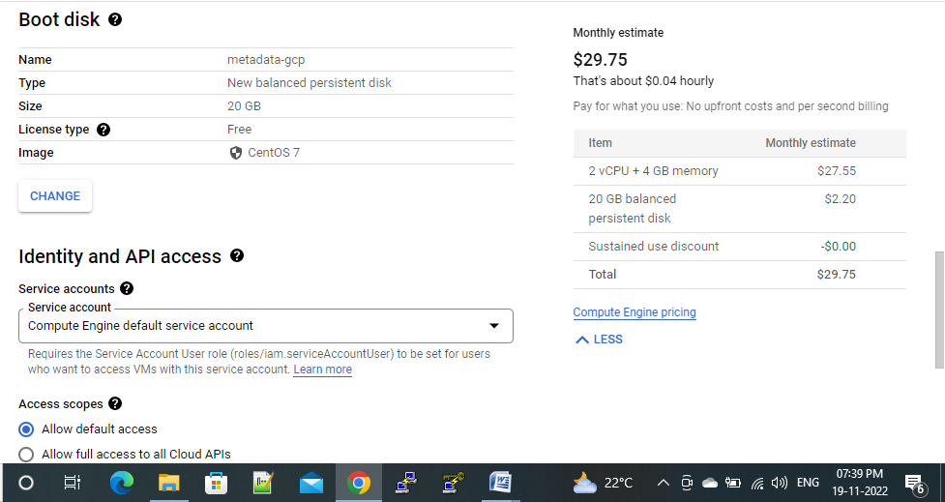

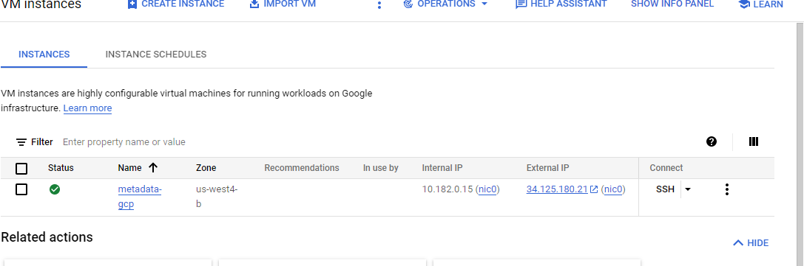

Once I have logged into the server, I have installed the dependencies or installations by using the command “**sudo yum install update -y**“ this command installs any latest installable available .

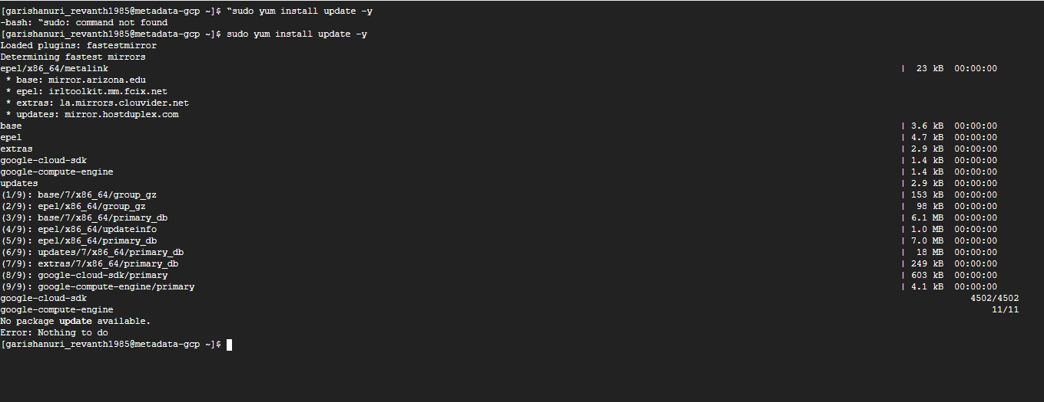

After installing the latest updates, I am installing the gitby using the command -

“sudo yum install git -y” - this command install the git in our Linux server.

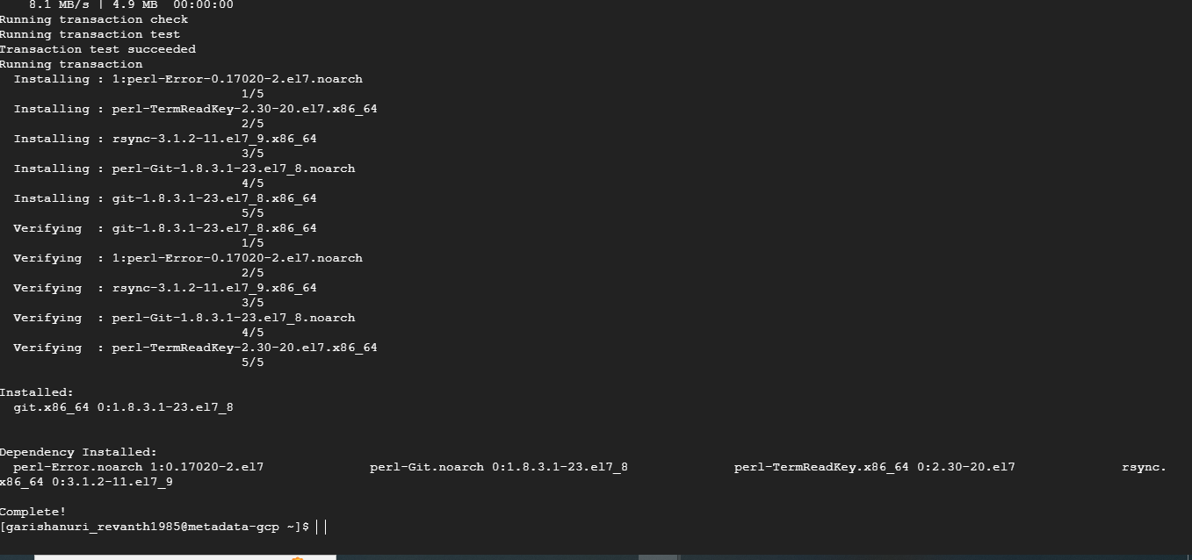

Now we have to install python by using the command - “ sudo yum install python -y”

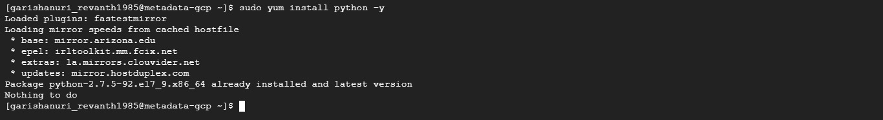

Now I have created a ssh key by using command –“ssh-keygen -t rsa “this will create an ssh key both public and private. Now after creating a ssh key, now change directory to “.ssh “by using

command - cd .ssh

Now for seeing file - command – **ls**

Now use command

cat id_rsa.pub – it is a public ssh key. Now copy that ssh key into the github.

Goto setting in “GitHub” and now goto “SSH KEYS AND GPG KEYS” – now paste the ssh key in the Add ssh key.

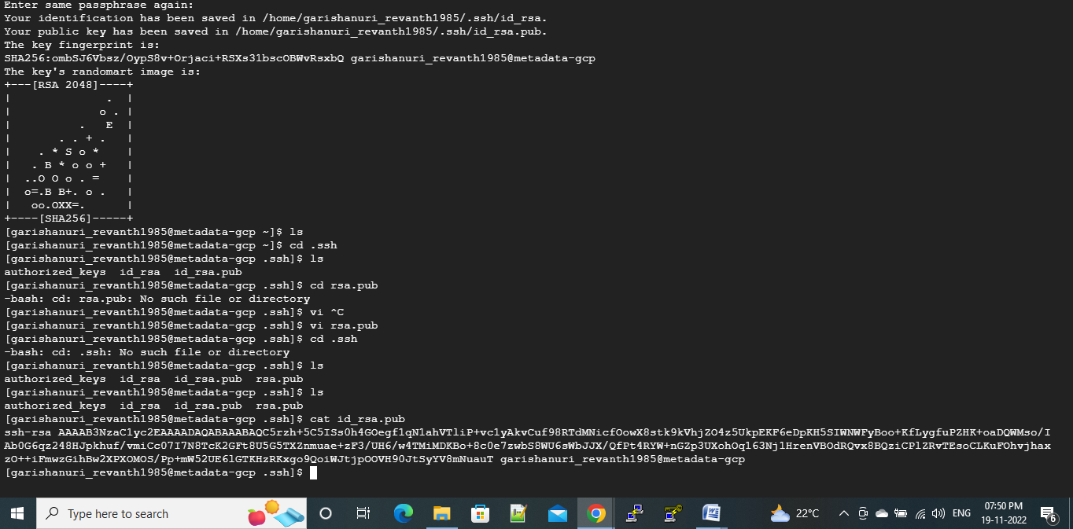

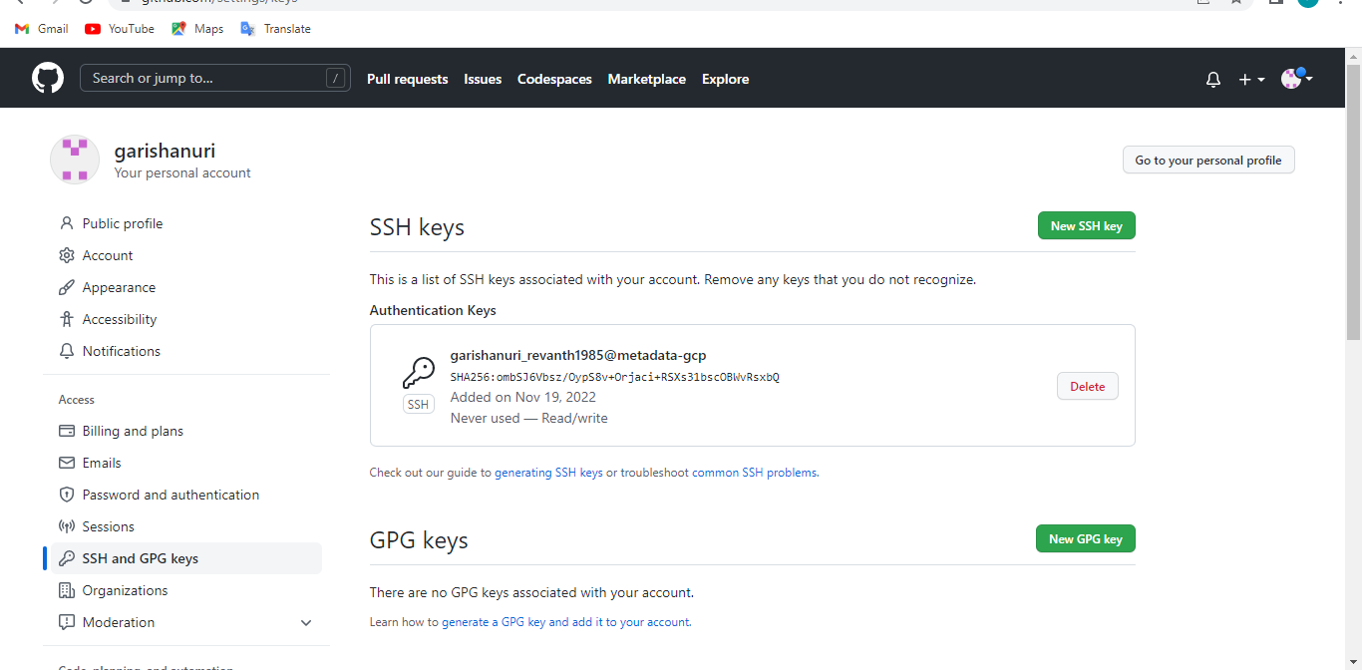

After saving our ssh key in the github ,now clone the git hub code to the vm instance through ssh .

For this run command – git clone

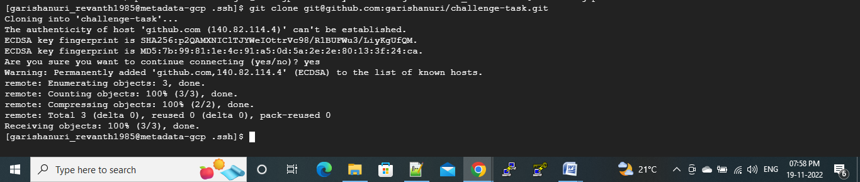

In the vm server to change directory - cdgcp-metadata-json-master

And then - cd src

Now - we have to change the ip address

Command –vi get_metadat.py

metadata_url = ‘http://34.125.134.161/latest/’

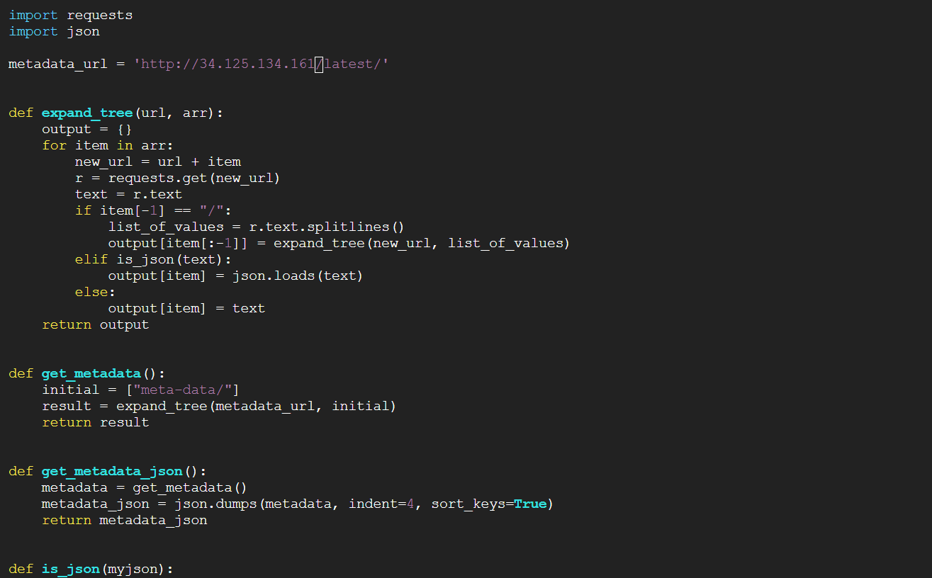

**For installing pipenv**

**sudo pip3 install pipenv**

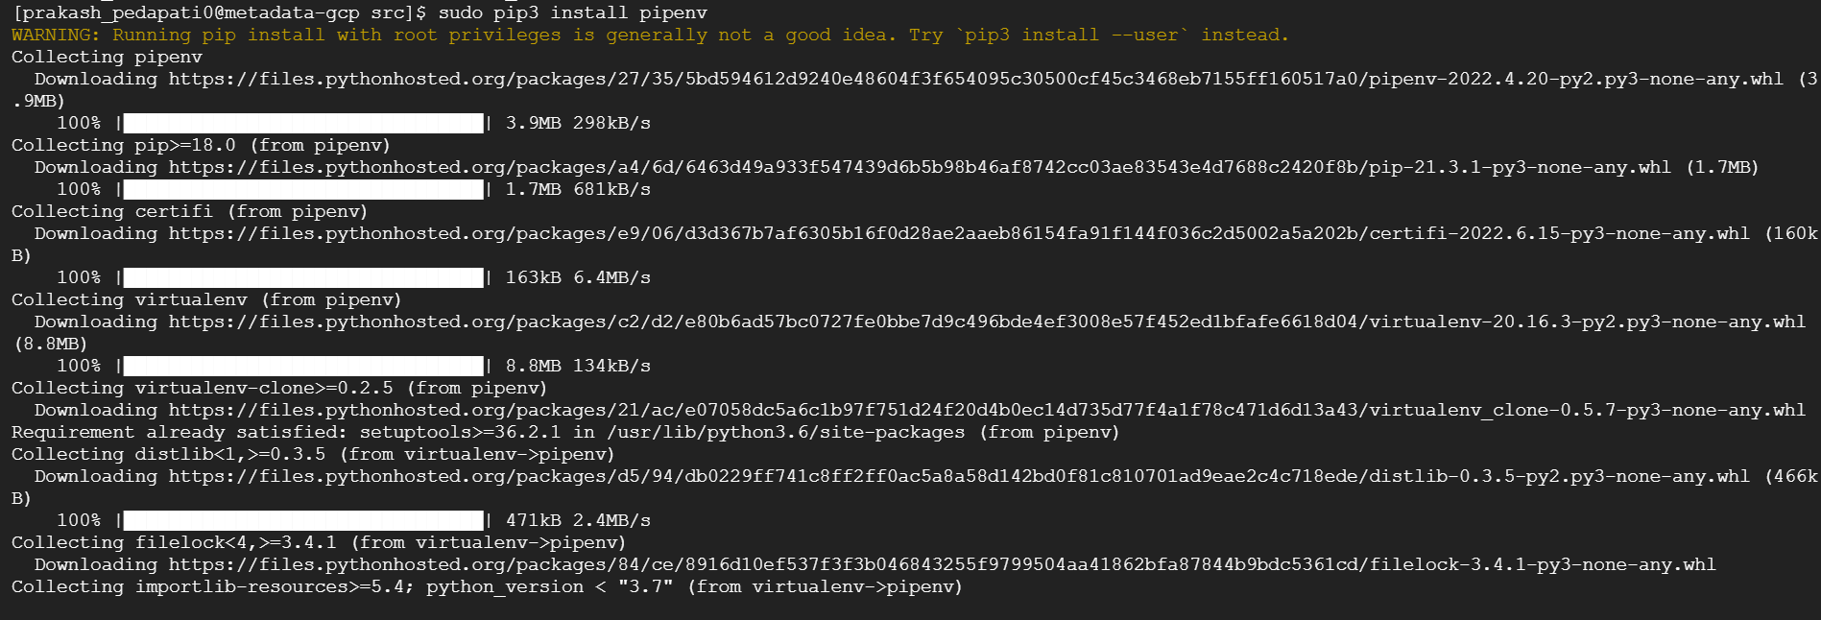

the repository on your instance

**cd gcp-metadata-json-master**

Install project dependencies

**pipenv install**

Now goto src (cd src)

Run command -**python3 get_metadata.py**

**Python get_key.py**

Open new browser we can open this URL **http://34.125.134.161/latest/** link-local address. And we will get Instance metatada is provided at this link.